**REGO ONLINE RESERVATION SYSTEM**

**Team Member:**

* Jie Zhu
* Jing Wang

**Project Purpose and Content**

* **Purpose**

This project will deliver an on line Reservation System for restaurants, in which restaurant owner can maintain restaurant and table information, and customer can search a restaurant and make a reservation.

* **Content**

The project will cover the following 2 main aspects:

1. Online reservation system
   * List restaurants by different criterion, such as Top Rated, New on REGO
   * Search restaurant
   * Make a reservation
2. Back-end restaurant management system
   * Maintain restaurant, such as location, hours of operation, cuisine style
   * Maintain table, such as capacity of each table, seating type, availability
   * Report of reservation

**Audience**

The people who are above 11 years old, love different type of food and good at using internet.

**List of Technologies, Libraries, Components used**

* **Technologies**  
  HTML, CSS, JavaScript, PHP, Database(MySql)
* **Libraries**  
  jQuery, Bing Maps
* **Framework**Laravel, Bootstrap

**Database Structure**

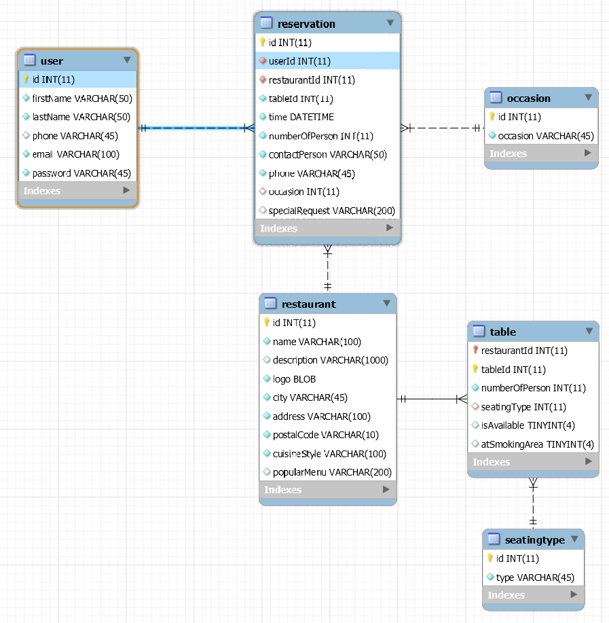

**Screenshots of Main Windows**

**HomePage**

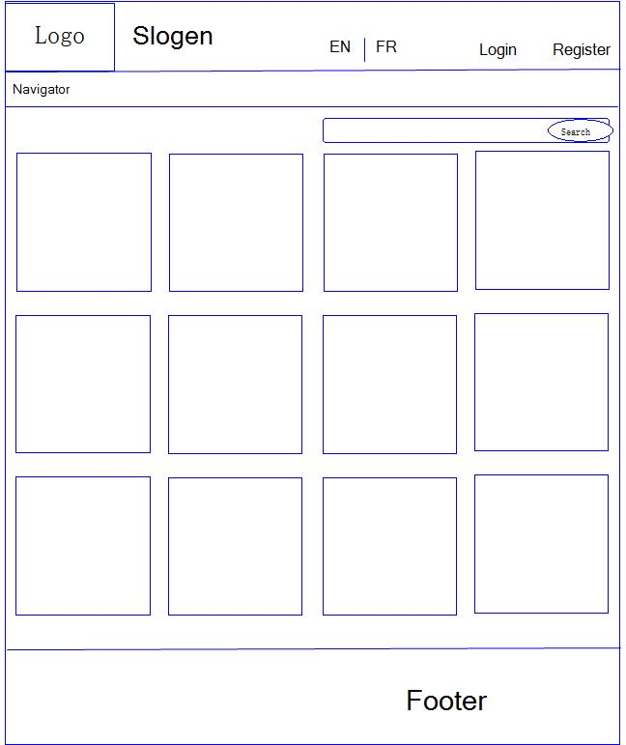

**Choose Table**

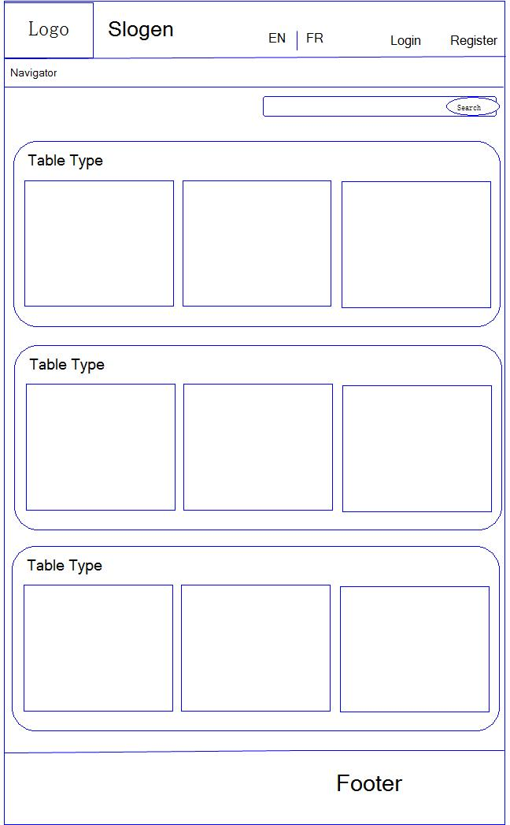

**Reservation**

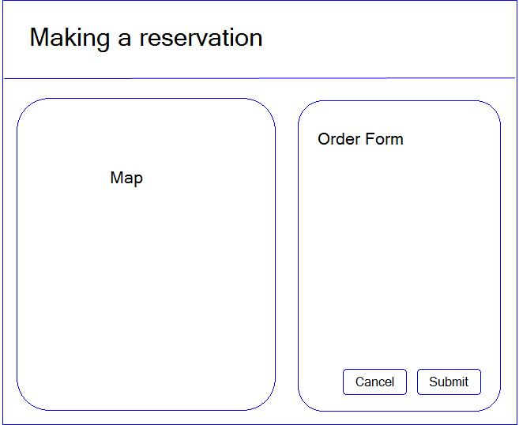

**Restaurant Management**

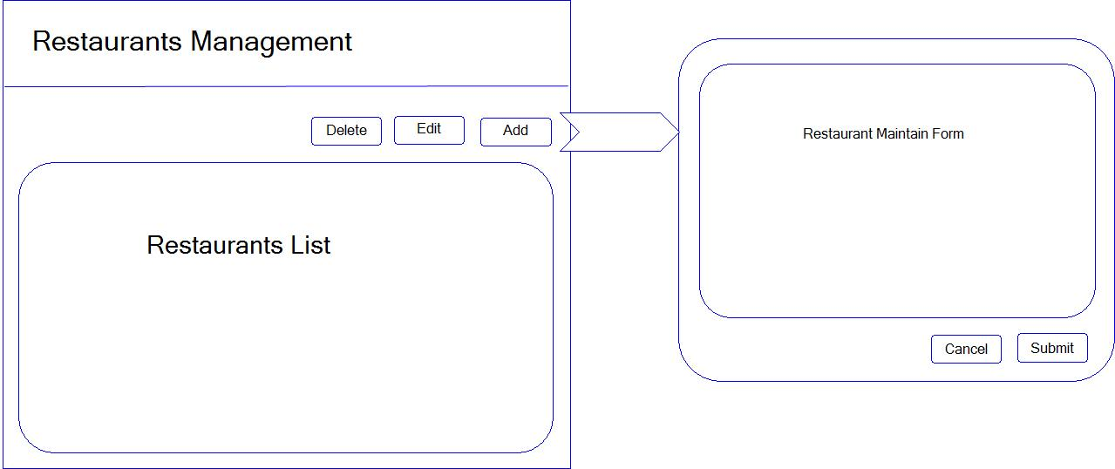

**Login (A Modal Dialog)**

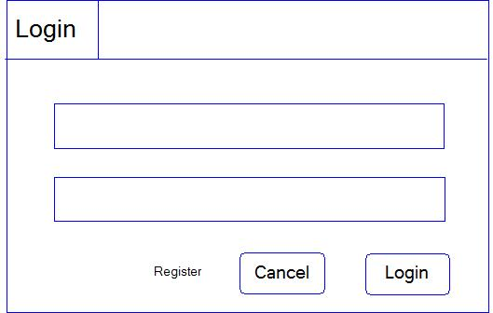

**Register (A Modal Dialog)**

